  
Practical-1 Infrastructure as a service using AWS.

SAP ID: 86092300041

**Date:-09/01/2024**

**Cloud Computing Architecture**

Cloud computing architecture refers to the design and structure of the components that make up a cloud computing environment. Cloud computing is a technology that allows users to access and use computing resources (such as servers, storage, databases, networking, software, and analytics) over the internet. The architecture of a cloud computing system is crucial for ensuring scalability, reliability, flexibility, and security. The cloud architecture is divided into 2 parts:

1. Frontend
2. Backend

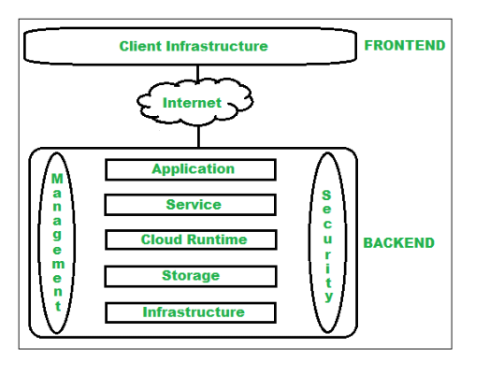

## Frontend :

Frontend of the cloud architecture refers to the client side of the cloud computing system. Means it contains all the user interfaces and applications which are used by the client to access the cloud computing services/resources. For example, use of a web browser to access the cloud platform.

In other words, it provides a GUI( Graphical User Interface ) to interact with the cloud.

## Backend :

Backend refers to the cloud itself which is used by the service provider. It contains the resources as well as manages the resources and provides security mechanisms. Along with this, it includes huge storage, virtual applications, virtual machines, traffic control mechanisms, deployment models, etc.

Application – Application in backend refers to a software or platform to which a client accesses.

Service – Service in backend refers to the major three types of cloud based services like SaaS, PaaS and IaaS.

Runtime Cloud – Runtime cloud in backend provides the execution and Runtime platform/ environment to the Virtual machine.

Storage – Storage in the backend provides flexible and scalable storage service and management of stored data.

Infrastructure – Cloud Infrastructure in backend refers to the hardware and software components of cloud like it includes servers, storage, network devices, virtualization software etc.

Management – Management in backend refers to management of backend components like application, service, runtime cloud, storage, infrastructure, and other security mechanisms etc.

Security – Security in backend refers to implementation of different security mechanisms in the backend for secure cloud resources, systems, files, and infrastructure to end-users.

Database– Database in backend refers to a database for storing structured data, such as SQL and NOSQL databases.

Networking– Networking in backend services that provide networking infrastructure for applications in the cloud, such as load balancing, DNS and virtual private networks.

## Benefits

* Makes the overall cloud computing system simpler.
* Improves data processing requirements.
* Helps in providing high security.
* Makes it more modularized.
* Results in better disaster recovery.
* Gives good user accessibility.
* Reduces IT operating costs.
* Provides high level reliability.
* Scalability.

# Infrastructure As A Service

Iaas is also known as Hardware as a Service (HaaS). It is one of the layers of the cloud computing platform. It allows customers to outsource their IT infrastructures such as servers, networking, processing, storage, virtual machines, and other resources. Customers access these resources on the Internet using a pay-as-per use model.

IaaS cloud computing platform layer eliminates the need for every organization to maintain the IT infrastructure.

IaaS is offered in three models: public, private, and hybrid cloud. The private cloud implies that the infrastructure resides at the customer-premise. In the case of public cloud, it is located at the cloud computing platform vendor's data center, and the hybrid cloud is a combination of the two in which the customer selects the best of both public cloud or private cloud.

IaaS provider provides the following services -

1. Compute: Computing as a Service includes virtual central processing units and virtual main memory for the Vms that is provisioned to the end- users.
2. Storage: IaaS provider provides back-end storage for storing files.
3. Network: Network as a Service (NaaS) provides networking components such as routers, switches, and bridges for the Vms.
4. Load balancers: It provides load balancing capability at the infrastructure layer.

## Advantages of IaaS cloud computing layer

1. Shared infrastructure - IaaS allows multiple users to share the same physical infrastructure.
2. Web access to the resources - Iaas allows IT users to access resources over the internet.
3. Pay-as-per-use model - IaaS providers provide services based on the pay-as-per-use basis. The users are required to pay for what they have used.
4. Focus on the core business - IaaS providers focus on the organization's core business rather than on IT infrastructure.
5. On-demand scalability - On-demand scalability is one of the biggest advantages of IaaS. Using IaaS, users do not worry about upgrading software and troubleshoot the issues related to hardware components.

# AWS & AWS services

Amazon Web Services (AWS) is a comprehensive and widely used cloud computing platform provided by Amazon.com. Launched in 2006, AWS offers a vast array of cloud services, including computing power, storage, databases, machine learning, analytics, networking, security, and more. It has become a key player in the cloud computing industry and serves millions of customers, ranging from startups and small businesses to large enterprises and government organizations.

Key Features and Services:

* Compute Services:
  + Amazon EC2 (Elastic Compute Cloud): Provides scalable virtual servers in the cloud, allowing users to run applications and workloads of various sizes.
  + AWS Lambda: A serverless computing service that enables developers to run code without provisioning or managing servers. It automatically scales based on demand.
* Storage Services:
  + Amazon S3 (Simple Storage Service): Offers scalable object storage with high durability. It is commonly used for storing and retrieving any amount of data.
  + Amazon EBS (Elastic Block Store): Provides block-level storage volumes for use with Amazon EC2 instances, offering persistent storage.
* Database Services:
  + Amazon RDS (Relational Database Service): Managed relational database service that supports multiple database engines, such as MySQL, PostgreSQL, Oracle, and Microsoft SQL Server.
  + Amazon DynamoDB: A fully managed NoSQL database service that provides fast and predictable performance with seamless scalability.
* Networking:
  + Amazon VPC (Virtual Private Cloud): Allows users to provision a logically isolated section of the AWS Cloud, giving them control over their virtual networking environment.
  + Amazon Route 53: A scalable domain name system (DNS) web service designed to route end-user requests to globally distributed AWS resources.
* Machine Learning and AI:
  + Amazon SageMaker: A fully managed service that enables developers to build, train, and deploy machine learning models quickly.
  + Amazon Polly and Amazon Rekognition: Services for text-to-speech and image and video analysis, respectively.
* Security and Identity:
  + AWS Identity and Access Management (IAM): Manages access to AWS services and resources securely.
  + Amazon GuardDuty: A threat detection service that continuously monitors for malicious activity and unauthorized behavior.
* Management and Monitoring:
  + AWS CloudWatch: Monitors AWS resources and applications in real-time, collecting and tracking metrics, and creating alarms.
  + AWS CloudTrail: Records API calls made on your account and delivers log files to your Amazon S3 bucket, providing visibility into user activity.
* Serverless Computing:
  + AWS Step Functions: Coordinates the components of distributed applications and microservices using visual workflows.
  + AWS SAM (Serverless Application Model): An open-source framework for building serverless applications.

Global Infrastructure:

AWS operates in multiple geographic regions, each consisting of multiple availability zones. This global infrastructure allows users to deploy applications close to their end-users, ensuring low-latency and high availability.

Pricing Model:

AWS follows a pay-as-you-go pricing model, where users pay only for the resources they consume. This flexibility allows organizations to scale their infrastructure up or down based on demand, optimizing costs.

# EC2

Amazon Elastic Compute Cloud (Amazon EC2) provides on-demand, scalable computing capacity in the Amazon Web Services (AWS) Cloud. Using Amazon EC2 reduces hardware costs so you can develop and deploy applications faster. You can use Amazon EC2 to launch as many or as few virtual servers as you need, configure security and networking, and manage storage. You can add capacity (scale up) to handle compute-heavy tasks, such as monthly or yearly processes, or spikes in website traffic. When usage decreases, you can reduce capacity (scale down) again.

The features of EC2 are:

* Instances: Virtual servers.
* Amazon Machine Images (AMIs): Preconfigured templates for your instances that package the components you need for your server (including the operating system and additional software).
* Instance types: Various configurations of CPU, memory, storage, networking capacity, and graphics hardware for your instances.
* Key pairs: Secure login information for your instances. AWS stores the public key and you store the private key in a secure place.
* Instance store volumes: Storage volumes for temporary data that is deleted when you stop, hibernate, or terminate your instance.
* Amazon EBS volumes: persistent storage volumes for your data using Amazon Elastic Block Store (Amazon EBS).
* Regions, Availability Zones, Local Zones, AWS Outposts, and Wavelength Zones: Multiple physical locations for your resources, such as instances and Amazon EBS volumes.
* Security groups: A virtual firewall that allows you to specify the protocols, ports, and source IP ranges that can reach your instances, and the destination IP ranges to which your instances can connect.
* Elastic IP addresses: Static IPv4 addresses for dynamic cloud computing.
* Tags: Metadata that you can create and assign to your Amazon EC2 resources.
* Virtual private clouds (VPCs): Virtual networks you can create that are logically isolated from the rest of the AWS Cloud. You can optionally connect these virtual networks to your own network.

**Steps:**Sign In to your aws acc

1. Select all services
2. Select EC2  
   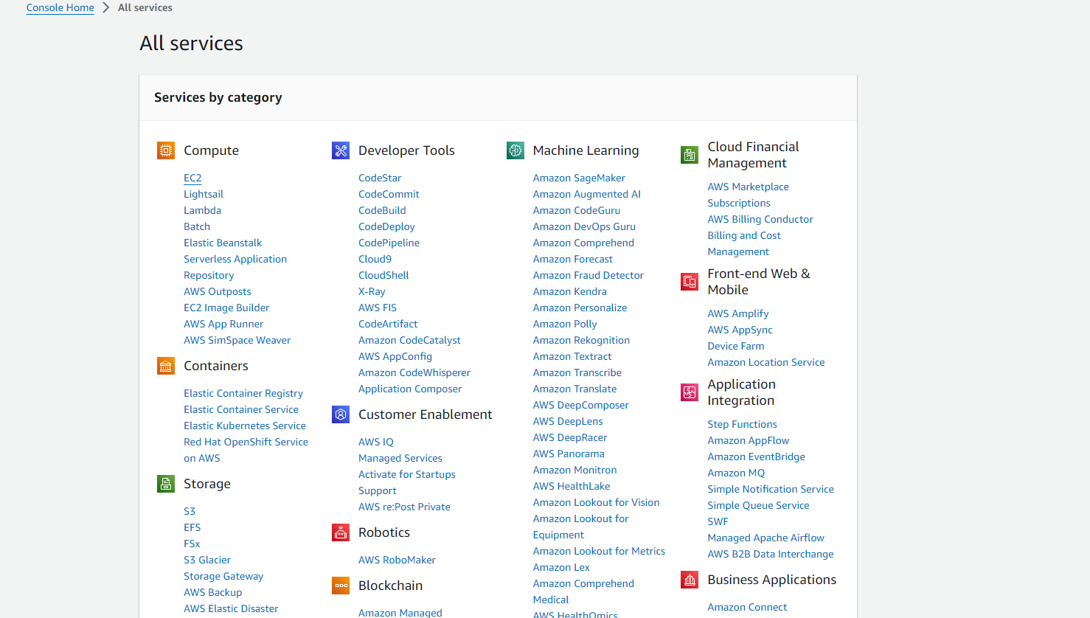
3. Launch Instance
4. Put name , create key value pair pem and save
5. Select Windows
6. Launch the instance
7. Go to instances and refresh  
   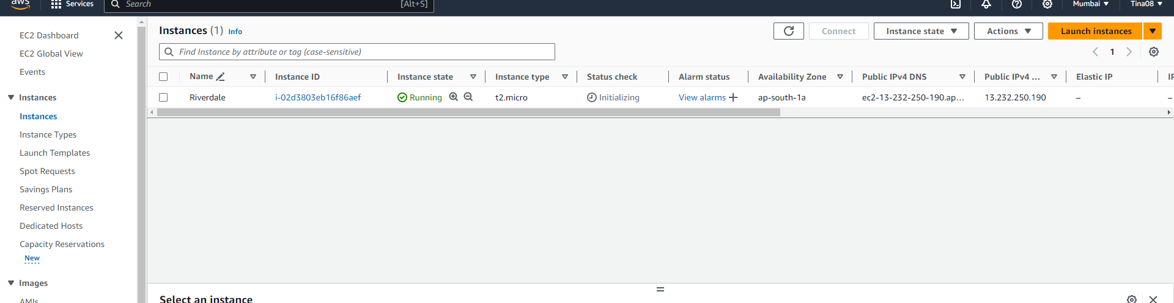
8. It will initialize and then start running
9. Select the instance   
   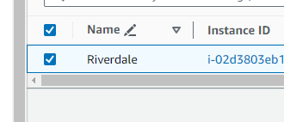
10. Click on connect, for connecting to RDP client
11. Click on get password and save the pass
12. Upload key value file  
    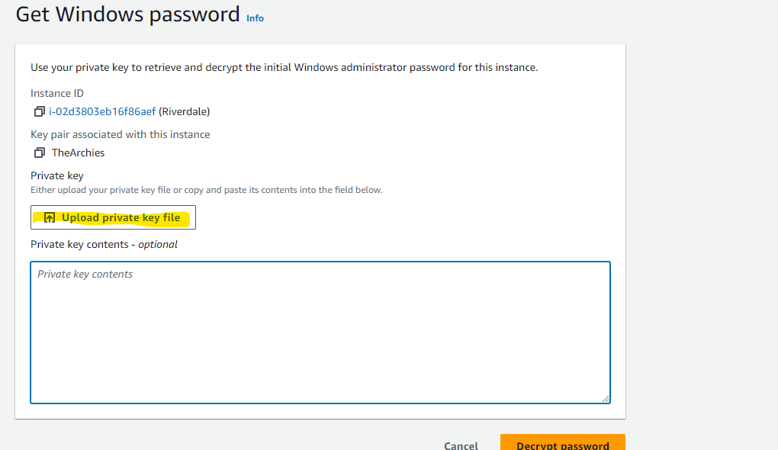
13. Decrypt pass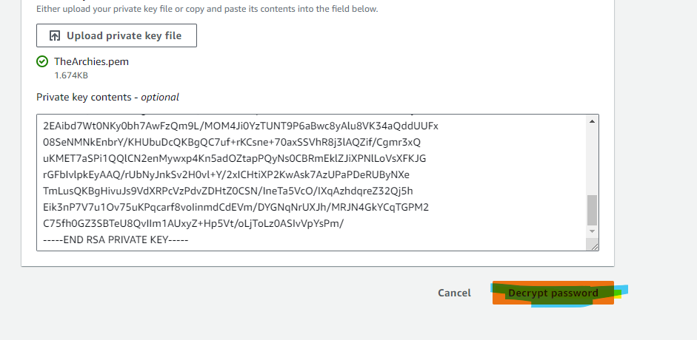
14. Save the pass- iM)7nJ34*VZ1-*BuqbsspMjYby;Z;C7G  
    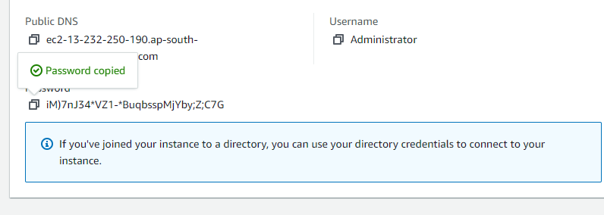
15. Go back to Instance , connect then download RDP file
16. Open RDP   
    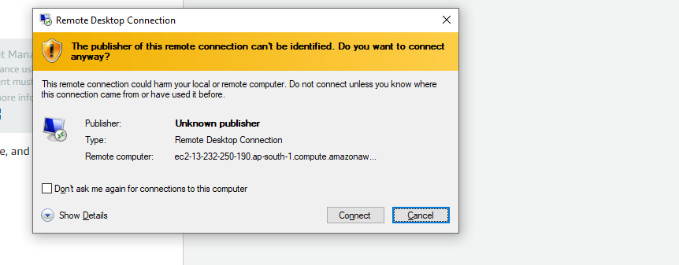
17. Connect RDP :  
    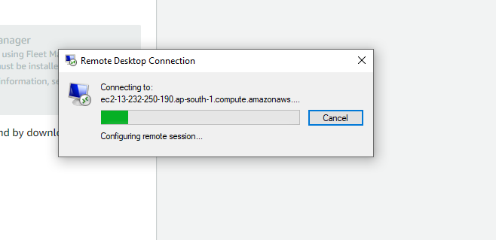
18. Enter creds  
    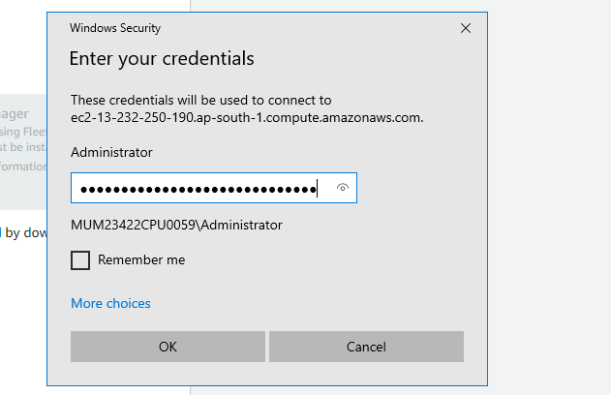
19. 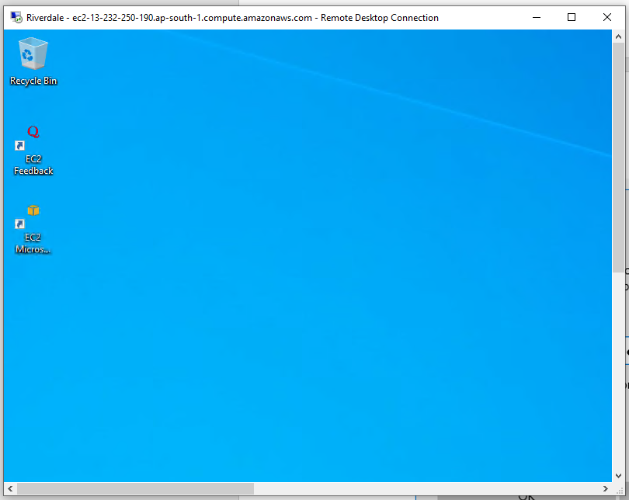
20. Close RDP
21. Go back to instances
22. Terminate the instance  
    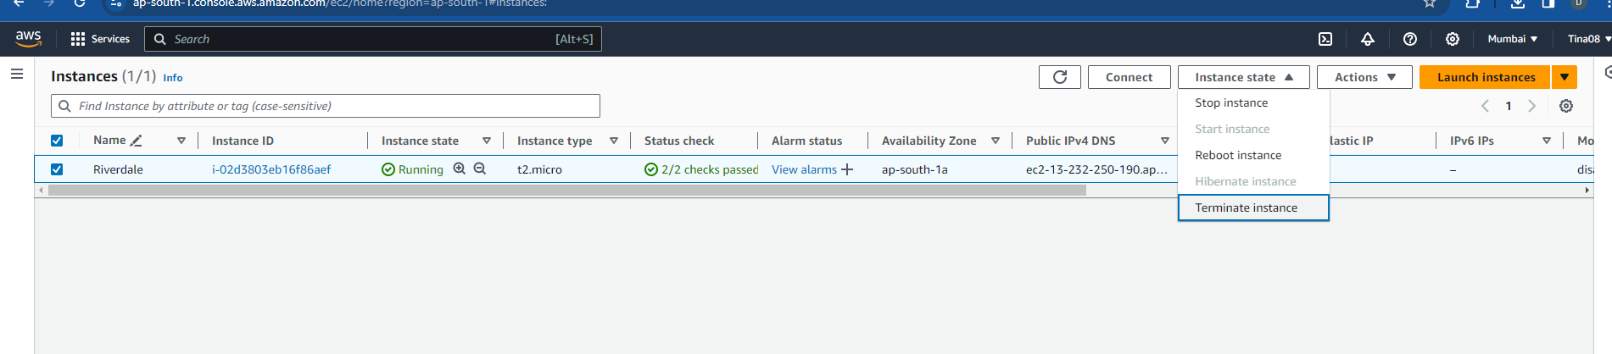  
    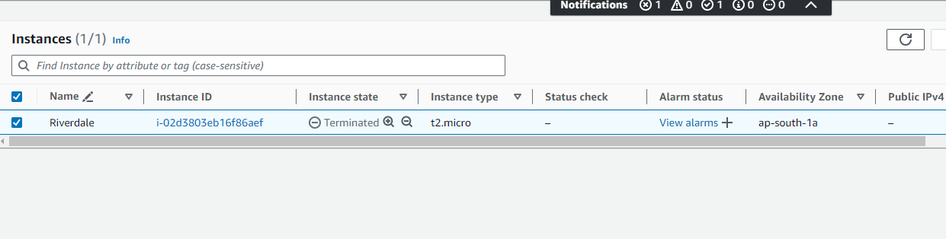
23. **Launch a new instance for Linux:**
24. Write a new web server name and Select Ubuntu server  
    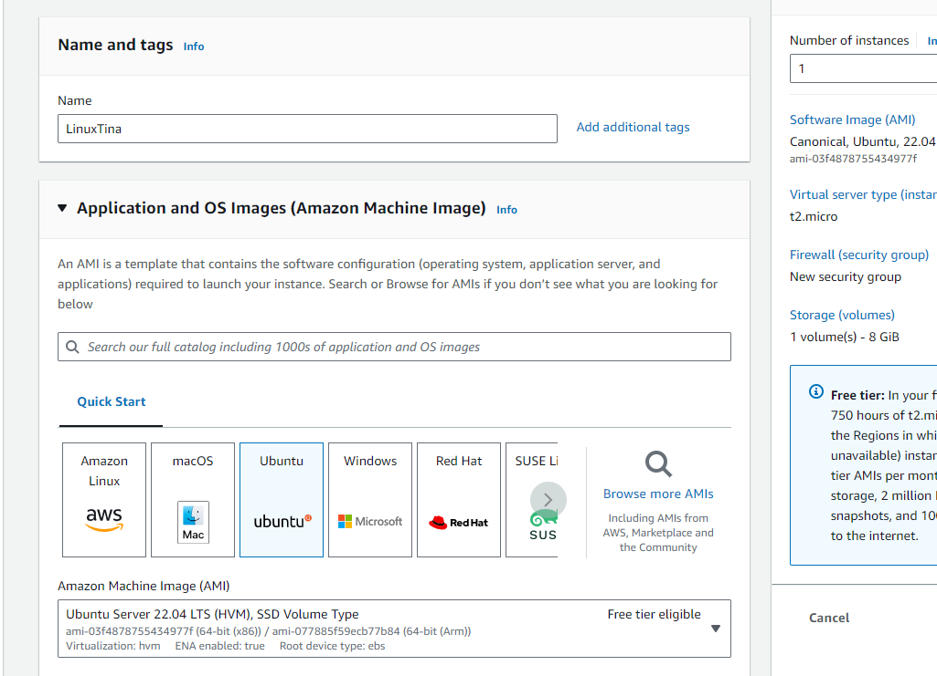
25. Create a new key value pair and select ppk  
    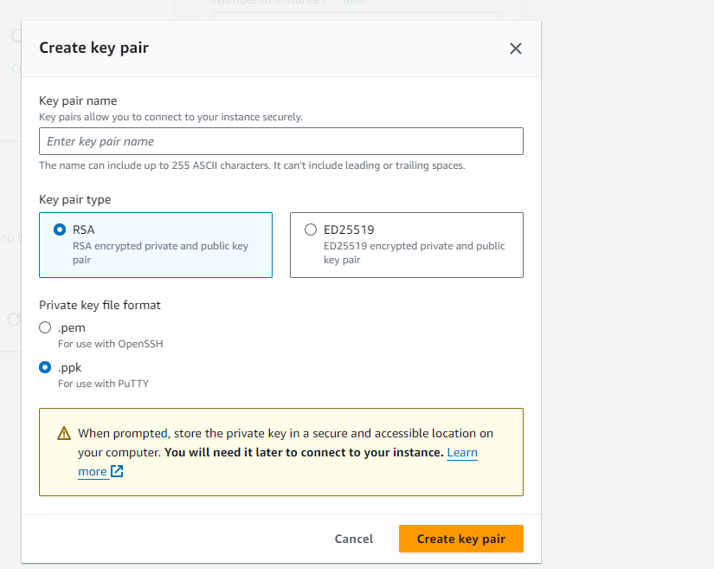
26. Download putty.exe from google
27. Select and downlad exe file  
    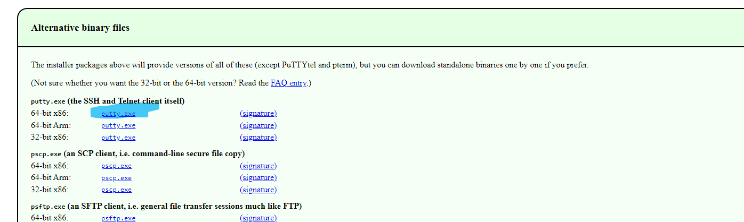
28. Create ppk key value pair and save the file
29. Allow all traffic  
    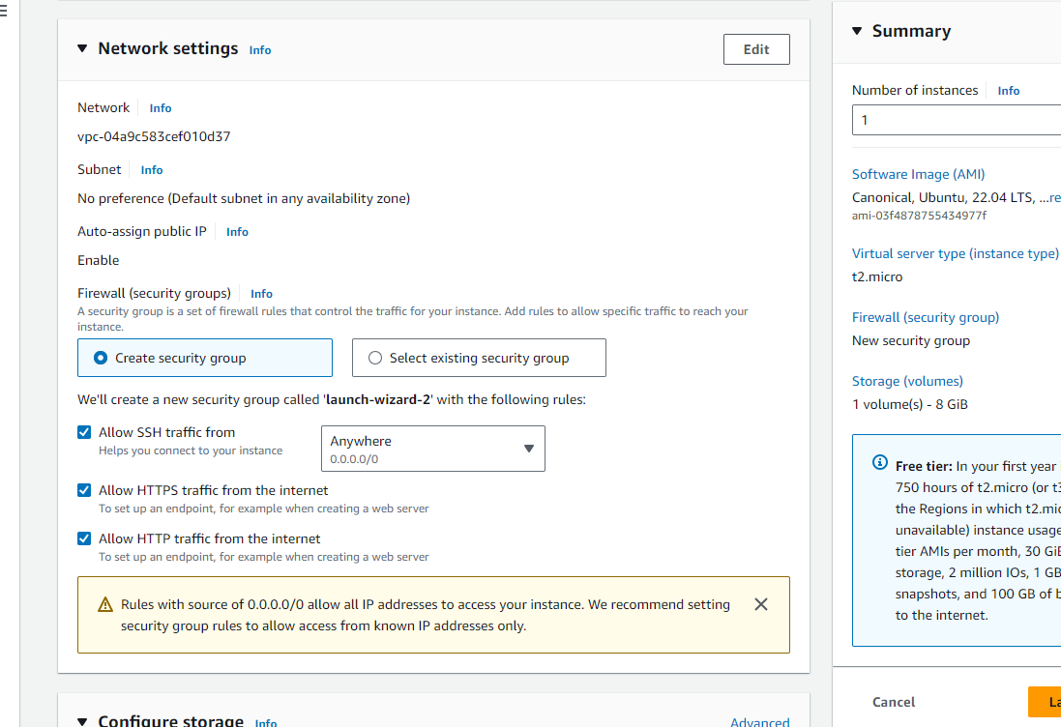
30. Launch Instance
31. Go to Instances and refresh
32. Select and copy Public IPV4 address  
    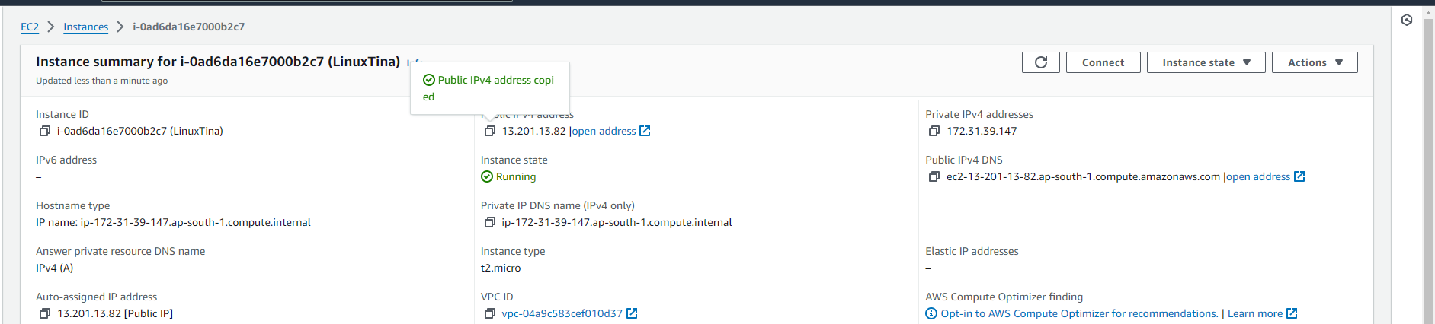
33. Go to putty, paste IP address  
    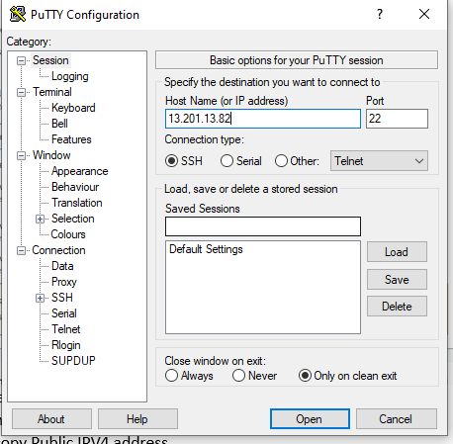
34. Category -> SSH -> Auth -> Credentials -> Browse and select ppk file  
    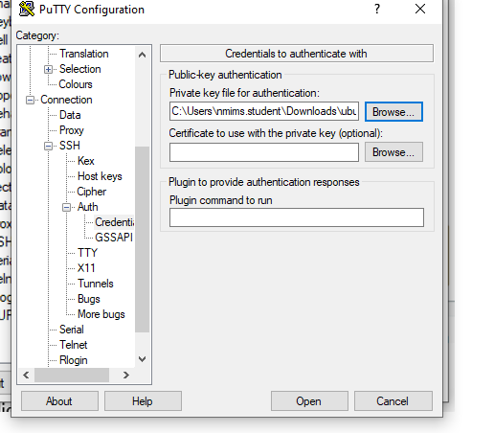
35. Putty will launch
36. Login as Ubuntu  
    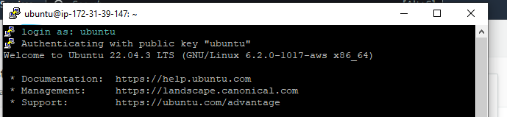
37. Type commands-   
    mkdir - Makes a directory  
    ls- lists down the files and folders in the directory  
    Control + D - Used to exit the file when inside Cat  
    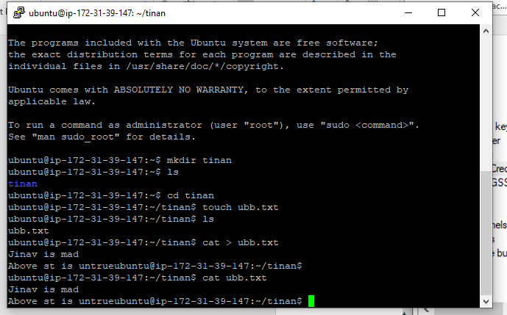  
    **control + D**
38. To Install Python3 and Firefox commands used are as follows:   
    1. sudo apt install python3  
    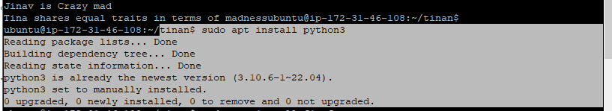
39. 2. sudo apt install firefox
40. 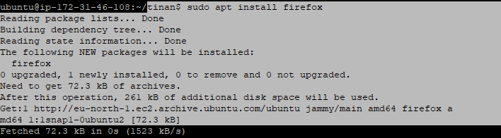
41. Type exit command to exit putty
42. Go back to instances in AWS and select the current instance  
    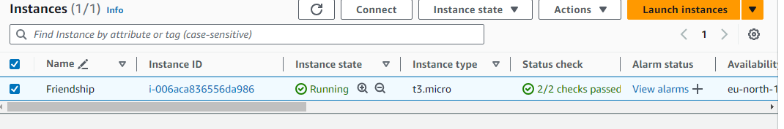
43. TO TERMINATE THE CURRENT RUNNING INSTANCE:  
    Instances ->Select Instance -> Instance state -> Terminate the Instance  
      
    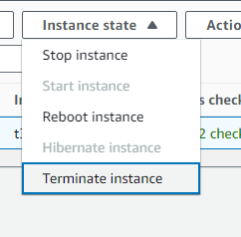  
      
      
      
    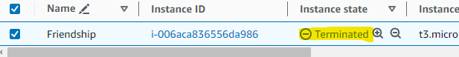
44. Terminate the Instance and close putty.